Kamran Gul | CMS: 023-25-0161 | CS AI (C) | Lab # 13

Task 1 & 2:
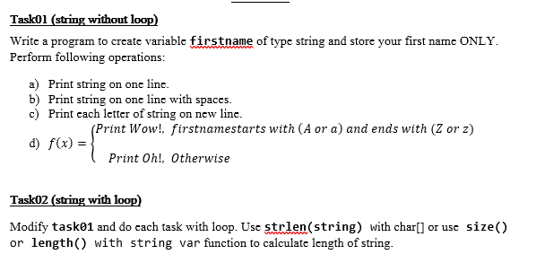
Solution:
#include<iostream>
using namespace std;
string checker(string name){
if((name[0]=='A' || name[0]=='a') && (name[7]=='Z' || name[7]=='z')){
return "Wow!";
}
else
return "Oh!";
}
int main(){
string firstname = "Muhammad";
// Task 1
cout<<"Task 1"<<endl;

//Part a
cout<<firstname[0]<<firstname[1]<<firstname[2]<<
firstname[3]<<firstname[4]<<firstname[5]<<
firstname[6]<<firstname[7];
cout<<endl;
// Part b
cout<<firstname[0]<<" "<<firstname[1]<<" "<<firstname[2]<<" "<<
firstname[3]<<" "<<firstname[4]<<" "<<firstname[5]<<" "<<
firstname[6]<<" "<<firstname[7]<<endl;
// Part c
cout<<firstname[0]<<endl;
cout<<firstname[1]<<endl;
cout<<firstname[2]<<endl;
cout<<firstname[3]<<endl;
cout<<firstname[4]<<endl;
cout<<firstname[5]<<endl;
cout<<firstname[6]<<endl;
cout<<firstname[7]<<endl;

// Task d
string check;
check = checker(firstname);
cout<<endl<<check<<endl;

// Task 2
cout<<"\n\nTask 2"<<endl;
// Part a
for(int i=0;i<firstname.length();i++){
cout<<firstname[i];
}
cout<<endl;
// Part b
for(int i=0;i<firstname.length();i++){
cout<<firstname[i]<<" ";
}
cout<<endl;
// Part c
for(int i=0;i<firstname.length();i++){
cout<<firstname[i]<<endl;
}
cout<<endl;
cout<<endl;
system("PAUSE");
return 0;
}

Output:
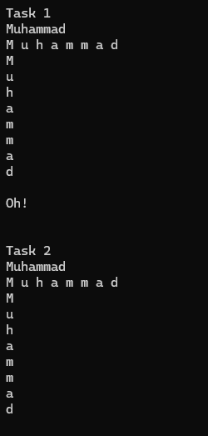

Task 3:
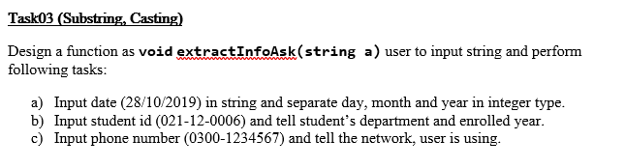
Solution:
#include<iostream>
#include<string>
using namespace std;
// 28/12/2000
void extract_info_ask(string a, string b, string c){
string d = a.substr(0,2);
int day = stoi(d);
cout<<"\nDay: "<<day<<endl;
string m = a.substr(3,2);
int month = stoi(m);
cout<<"Month: "<<month<<endl;
string y = a.substr(6,4);
int year = stoi(y);
cout<<"Year: "<<year<<endl;

cout<<endl;

string depart = b.substr(0,3);
if(depart== "021"){
cout<<"Media Department";
}
else if(depart== "022"){
cout<<"Buisness Department";
}
else if(depart== "023"){
cout<<"CS Department";
}
else
cout<<"Wrong CMS entered...";

int ad_year = stoi(b.substr(4,2));
cout<<endl<<"Year of Admission: 20" << ad_year<<endl;

cout<<endl;

string op = c.substr(0,3);
if(op == "033"){
cout<<"Ufone operator";
}
else if(op == "031"){
cout<<"Jazz operator";
}
else if(op =="034"){
cout<<"Zong operator";
}
else
cout<<"Wrong number entered...";
}
int main(){
// Part a
string date;
cout<<"Enter Date (dd/mm/yyyy): ";
cin>>date;

// Part b
string id;
cout<<"Enter your CMS id (000-00-0000): ";
cin>>id;

// Part c
string phone;
cout<<"Enter your phone number (0000-0000000): ";
cin>>phone;
extract_info_ask(date,id,phone);

return 0;
}
Output:
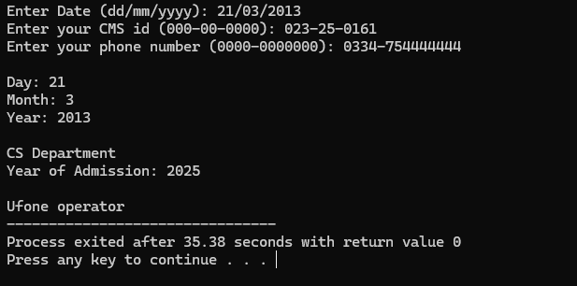
Task 4:
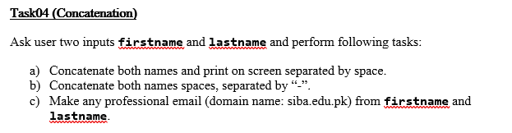
Solution:
#include<iostream>
#include<cstring>
using namespace std;
int main(){
string firstname, lastname, fullname, email;
cout<<"Enter your first name: ";
cin>>firstname;
cout<<"Enter your last name: ";
cin>>lastname;

fullname = firstname + lastname;

for(int i = 0; i<fullname.length();i++){
cout<<fullname[i]<<" ";}
cout<<endl;
for(int i = 0; i<fullname.length();i++){
cout<<fullname[i];
if(i==fullname.length()-1) break;

cout<<"-";}
cout<<endl;
email = fullname + "@suk-iba.edu.pk";
cout<<"Email Adress: "<< email;
return 0;
}
Output:
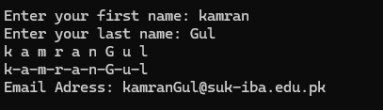
Task 5:
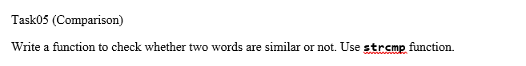
Solution:
#include<iostream>
using namespace std;
void comparison(char a[20], char b[20]){
if(strcmp(a,b) == 0)
cout<<"Strings are equal";
else
cout<<"Strings are not equal";
}
int main(){
char first[20], second[20];
cout<<"Enter first string: ";
cin>>first;
cout<<"Enter second string: ";
cin>>second;
comparison(first,second);

return 0;
}
Output:
